Checking for Magic Squares

A program that checks to see if the sum of the rows, columns, and diagonals of a square matrix are equal. (Also known as a check for a magic square)
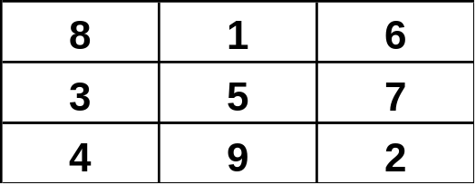

public class Magic
{
private static final int ROWS = 3;
private static final int COLS = 3;
public static void main(String[] args)
{
int[][] matrix = new int[ROWS][COLS];

init (matrix);

if (rowsEqual(matrix) && colsEqual(matrix) &&
diagCheck(matrix))
System.out.println("It's A Magic Square!");
else
System.out.println("It's Not A Magic Square!");
}

private static void init (int[][] matrix)
{

FileReader fileIn = new FileReader(file);
BufferedReader in = new BufferedReader(fileIn);

int[][] square = new int[3][3];
int j = 0;

while(true) {

String line = in.readLine();
if (line == null) // EOF
break;

StringTokenizer s = new StringTokenizer(line);
}

private static boolean rowsEqual (int[][] matrix)
{
int[] rowSum = new int[ROWS];

for (int i = 0; i < matrix.length; i++)
{
rowSum[i] = 0;
for (int j = 0; j < matrix[i].length; j++)
rowSum[i] += matrix[i][j];
}

for (int i = 1; i < rowSum.length; i++)
if (rowSum[i] != rowSum[0])
return false;

return true;
}

private static boolean colsEqual (int[][] matrix)
{
int[] colSum = new int[COLS];

for (int j = 0; j < matrix[0].length; j++)
{
colSum[j] = 0;
for (int i = 0; i < matrix.length; i++)
colSum[j] += matrix[i][j];
}

for (int i = 1; i < colSum.length; i++)
if (colSum[i] != colSum[0])
return false;

return true;
}

private static boolean diagCheck(int[][] matrix)
{
int[] diagSum = {0, 0};

for (int i = 0; i < matrix.length; i++)
diagSum[0] += matrix[i][i];

for (int i = 0; i < matrix.length; i++)
diagSum[1] += matrix[i][matrix.length-i-1];

for (int j = 0; j < matrix[0].length; j++)
rowSum += matrix[0][j];

return (diagSum[0] == diagSum[1] &&
diagSum[0] == rowSum );
}
}

